WAP to demonstrate all the methods in datetime module.

-> datetime

     - year

     - month

     - day

     - timedelta

     - strftime

     - datetime.strptime

import datetime

from time import strftime, time

x=datetime.datetime.now()

print('Current date & time:-',x)

**#year**

print('Year:-',x.year)

**#month**

print('Month:-',x.month)

**#day**

print('Day:-',x.day)

**#timedelta**

today=datetime.datetime.today()

day=today+datetime.timedelta(days=1,weeks=1)

**#strftime**

y=datetime.date(year=2021,month=5,day=26)

print('Month in word:-',y.strftime("%B"))

print('Day in word:-',y.strftime("%A"))

**#strptime**

print('Date after 1 week and 1 day from today=',day)

date=input('Enter Date in format (DD-MM-YYYY)=')

pdate=datetime.datetime.strptime(date,'%d-%m-%Y')

print(pdate)

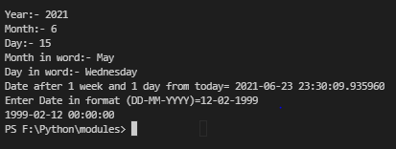

-> time

    - hour

    - minute

    - second

import datetime

from time import strftime, time

t=datetime.time(12,25,35)

print('Hour:-',t.hour)

print('Minute:-',t.minute)

print('Second:-',t.second)

